|  |  |  |  |
| --- | --- | --- | --- |
| 1 | | 90,000.0 | |
| NUMERO DE FRONTERAS | | ENERGIA AGREGADA | |
|  | | | |
| SI | | 26-10-2020 | |
| CONTRATO | | VENCIMIENTO CONTRATO | |
|  | | | |
| 232,753,461 | 107 | | 9,923,020 |
| INGRESO 2019 | DÍAS CERTIFICADOS 2019 | | ENERGIA RESPALDADA 2019 |
|  | | | |
| 383,017,777 | 162 | | 14,345,178 |
| INGRESO 2020 | DÍAS CERTIFICADOS 2020 | | ENERGIA RESPALDADA 2020 |
|  | | | |
| 325,114,701 | 156 | | 14,036,146 |
| INGRESO 2021 | DÍAS CERTIFICADOS 2021 | | ENERGIA RESPALDADA 2021 |

|  |
| --- |
| **CERAMICA SAN LORENZO**  USUARIO |

|  |
| --- |
| **Mateo Porras**  Ejecutivo de cuenta |

|  |
| --- |
| **Enrique Gordillo / 0 / egordillo@sanlorenzo.com.co**  Primera fecha: PUNTO FOCAL |

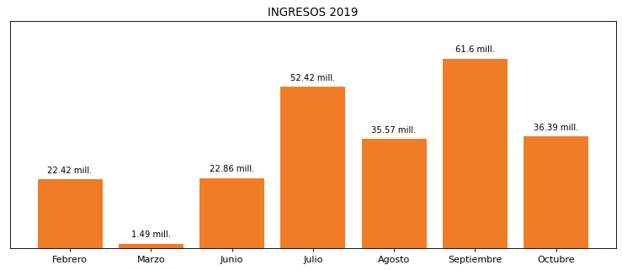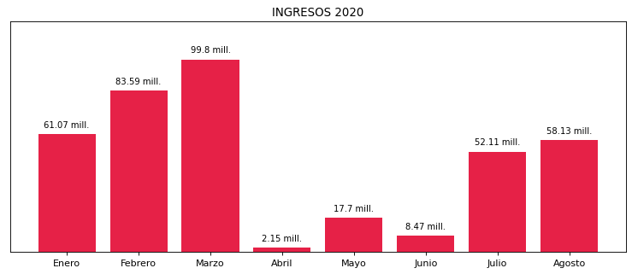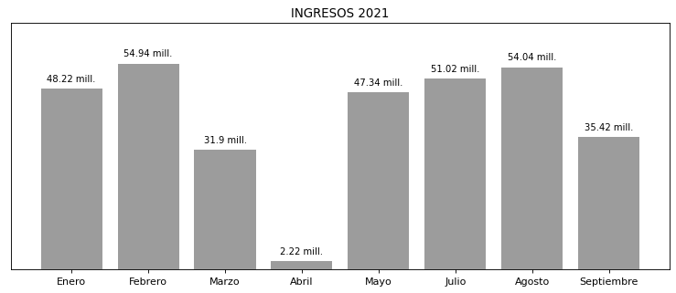

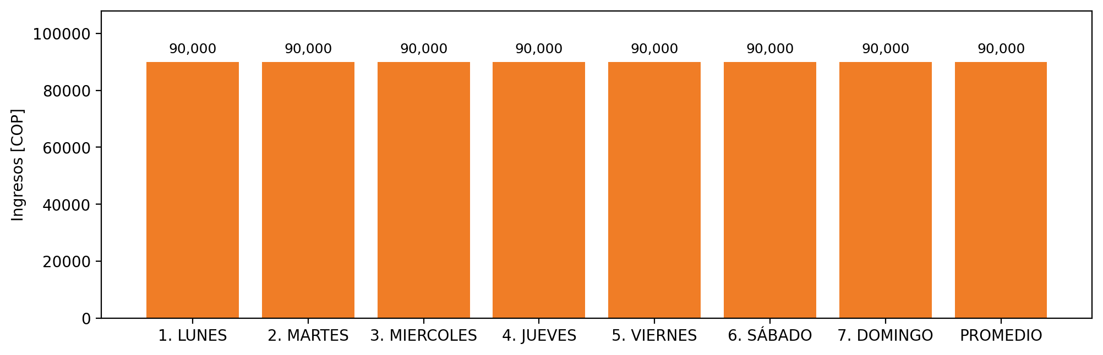

|  |  |  |  |  |  |  |  |  |  |
| --- | --- | --- | --- | --- | --- | --- | --- | --- | --- |
| **FRONTERA COMERCIAL** | **TIPO DDV** | **COD SIC** | **PREDIO** | **PROMEDIO** | **MARGEN** | **ÚLTIMA DESCONEXION** | **DÍAS CERTIFICADOS** | **ACTUALIZACION** | **PROXIMA PRUEBA DDV** |
| CERAMICA SAN LORENZO INDUSTRIAL DE COLOMBIA S.A. | Frt36275 | Frt22236 | Prd01533 | 90,000 | NO APLICA | 2021-06-29 | 68.0 | 2023-04-15 | 2021-11-30 |